1. On your Windows laptop or PC, open 'System Information' and take a screenshot showing your OS version, processor, and RAM details.
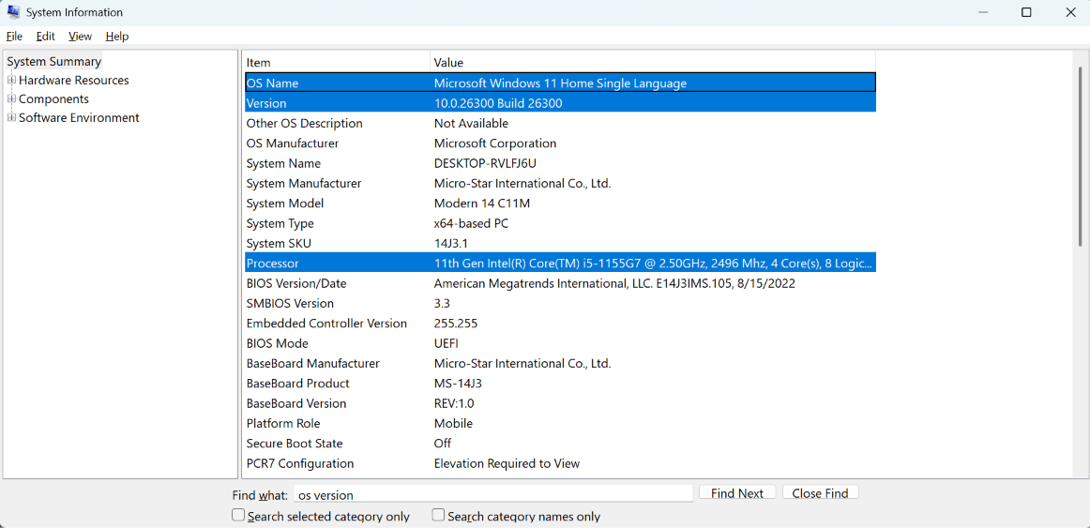
Answer

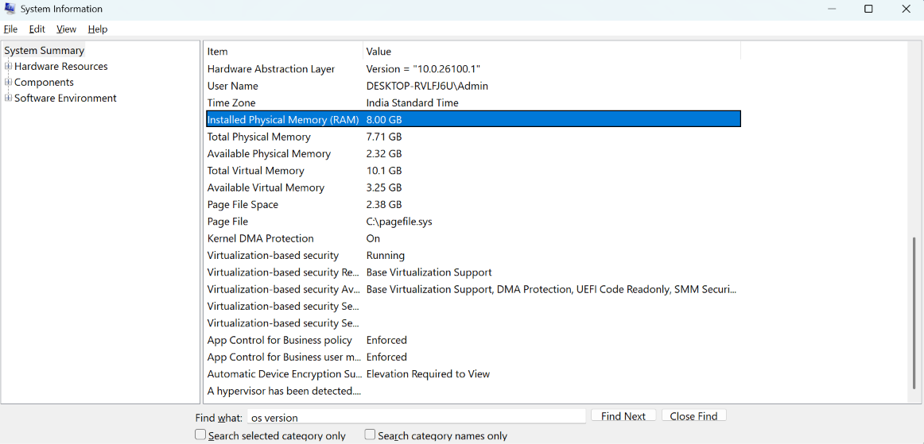

2. Download any official Linux distribution ISO (like Ubuntu or Fedora), and use Rufus or BalenaEtcher to create a bootable USB drive for installation. Hint: If you don't have a spare USB, use a virtual machine tool like VirtualBox to mount the ISO and start the installation process virtually.
Answer
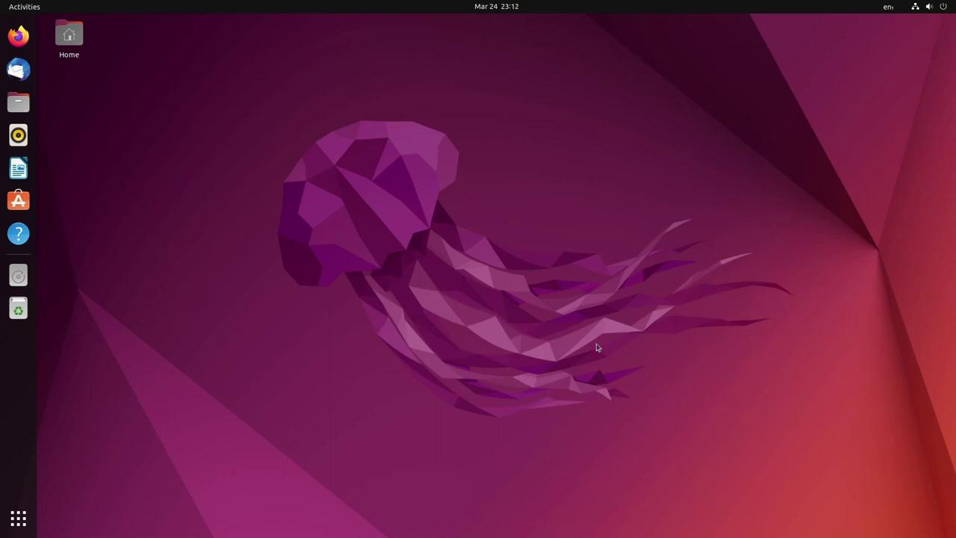
Step 1: Download Ubuntu:
- Visit the official Ubuntu website and download the Ubuntu Desktop ISO.

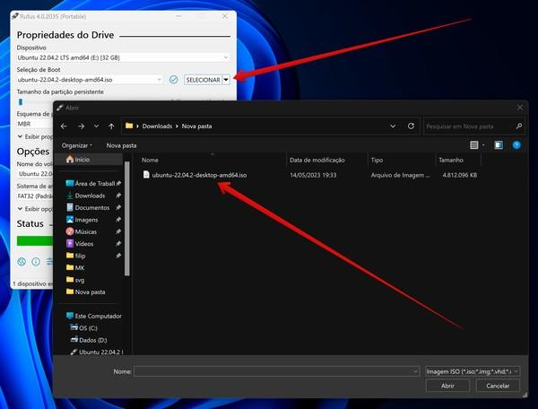
Step 2: Download Rufus:
- Get Rufus from its official website.
- Download Rufus
- Connect a USB drive with at least 8 GB of capacity.

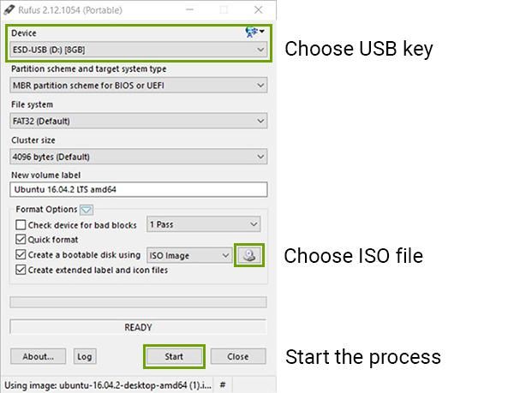
Step 3: Create the bootable USB:
- Open Rufus.
- Select the correct USB device.
- Click SELECT and choose the downloaded Ubuntu ISO.
- Keep the recommended settings unless you know you need different ones.
- Click START and follow the prompts.

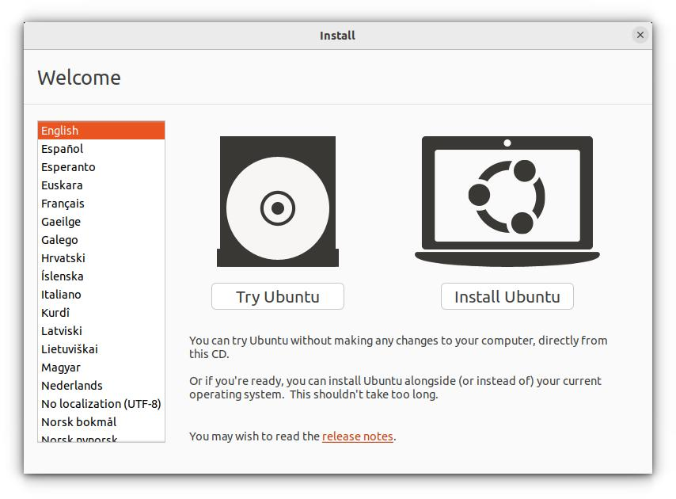
Step 4: Verify the USB:
- When Rufus finishes, safely eject the drive. You can boot from it using your computer's boot menu and choose Try Ubuntu to test Linux without installing it to your computer.

Use VirtualBox without a USB drive

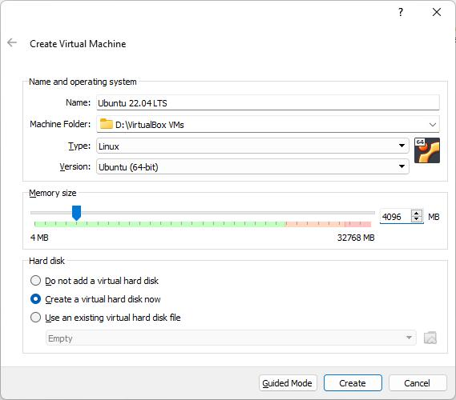
1. Download VirtualBox:
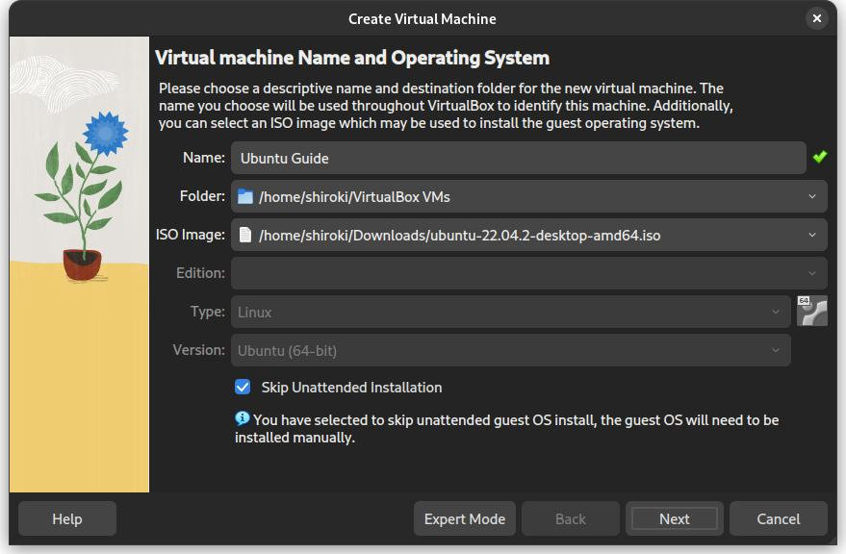
2. Create a virtual machine:
- Open VirtualBox, select New, choose Linux/Ubuntu, and attach the downloaded ISO file.

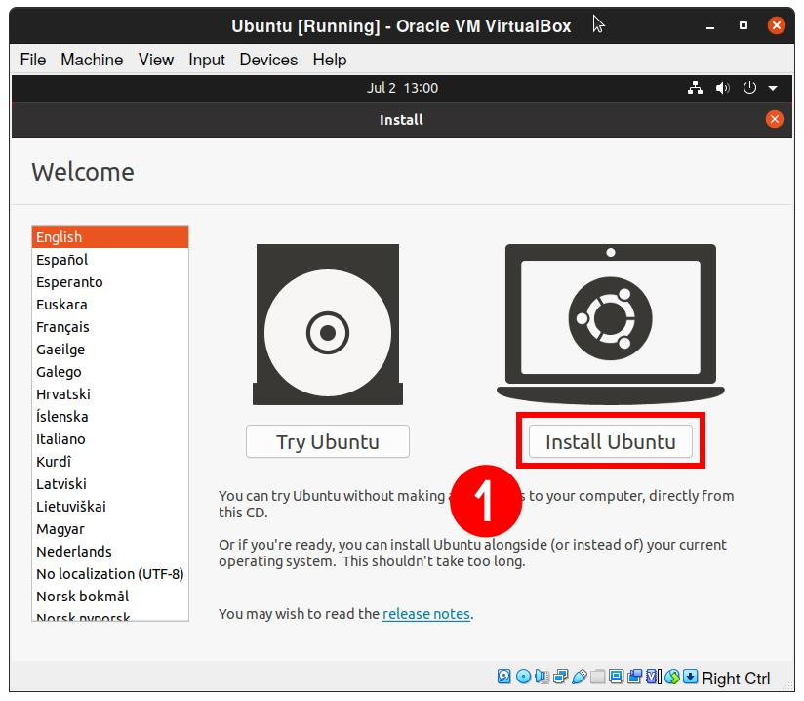
3. Start the installation:
- Allocate suitable RAM and virtual disk space, then start the VM. Follow the Ubuntu installer inside the virtual machine. This installs Linux in the VM rather than replacing Windows.
3. On a macOS device (or using a macOS virtual machine), open 'System Preferences' and change the desktop wallpaper, then adjust the system language to Hindi or Gujarati. Hint: Find 'Language & Region' in System Preferences to add or change languages.
Answer

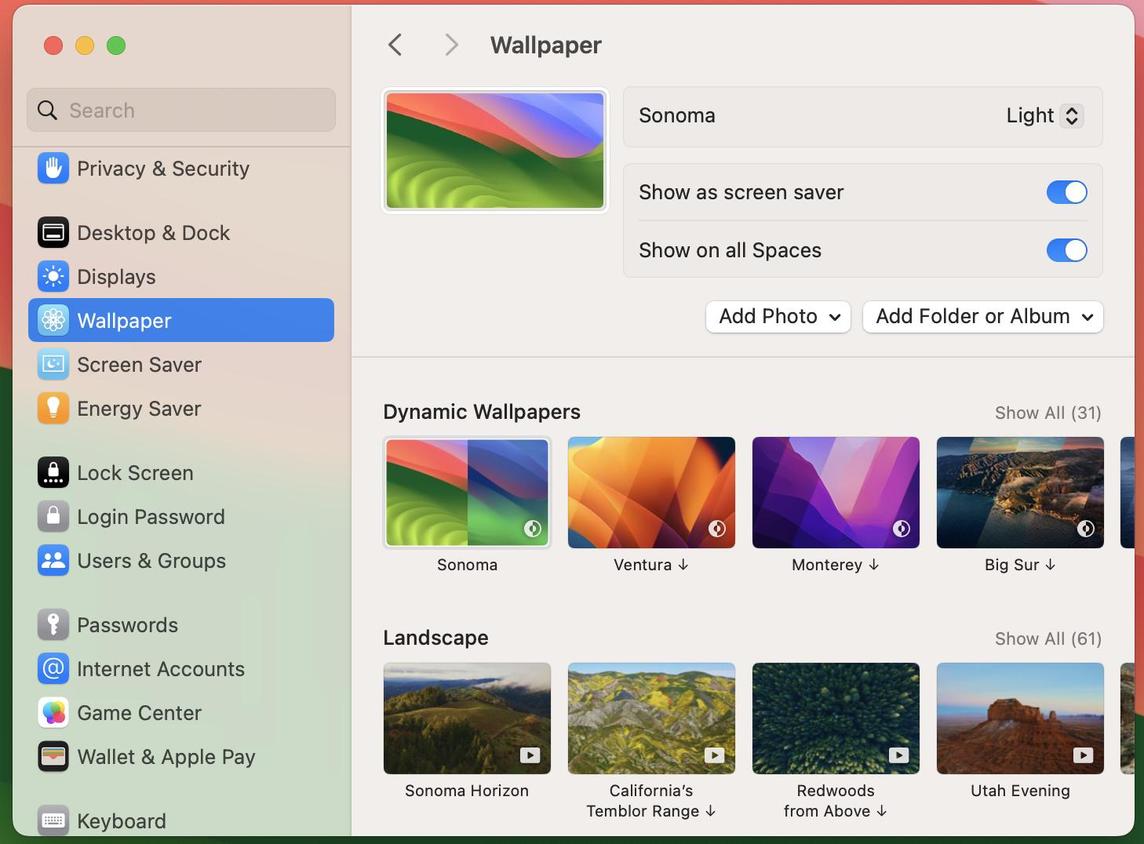
Step 1: Change the desktop wallpaper:
- Open your Mac and click the Apple menu.
- Open System Settings (called System Preferences on older macOS versions).
- Click Wallpaper.
- Choose a wallpaper from the available options, or select an image from your files.
- Confirm that the desktop background has changed.

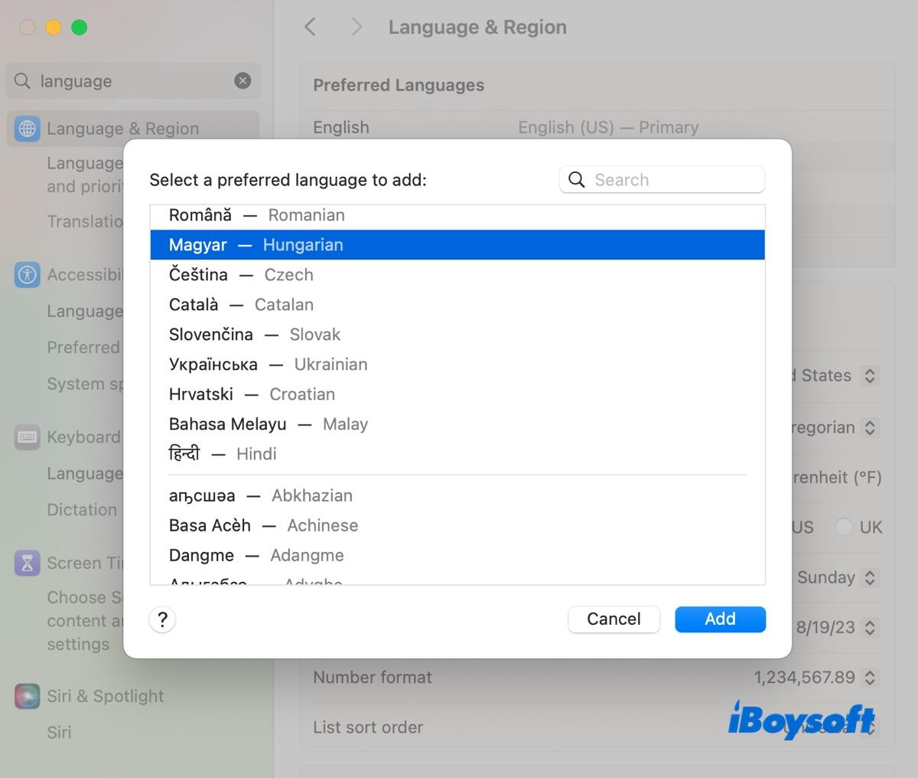
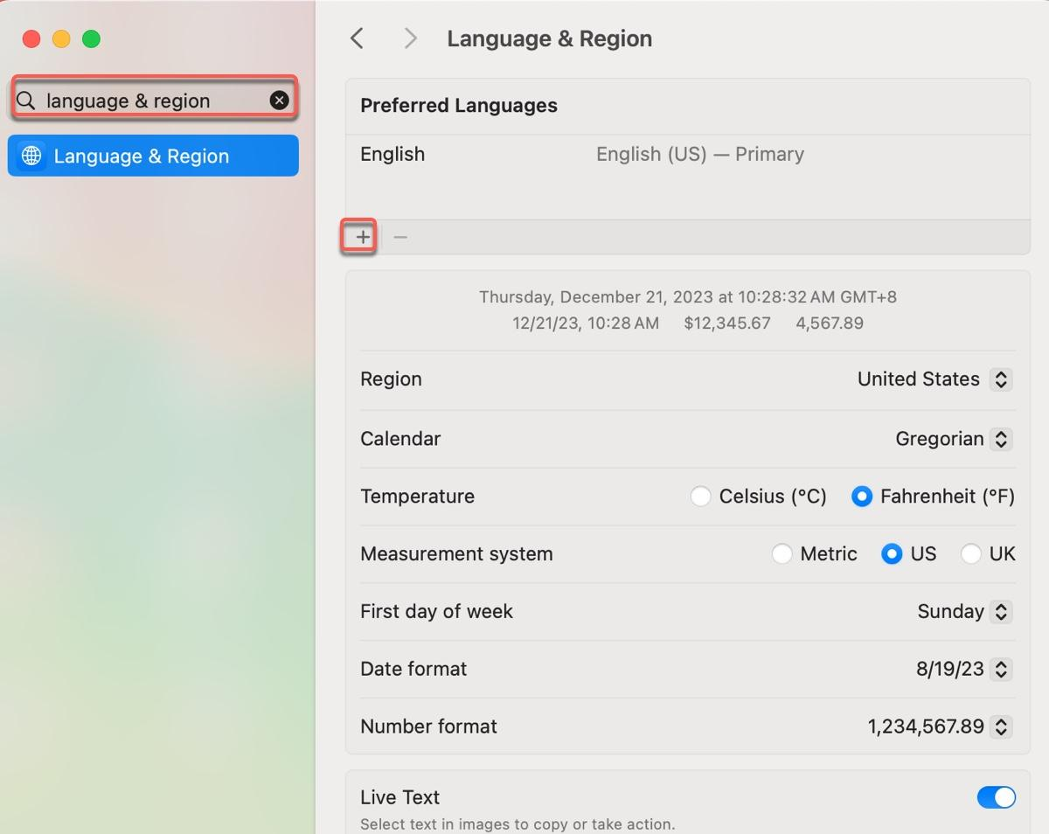
Step 2: Change the system language to Hindi or Gujarati:
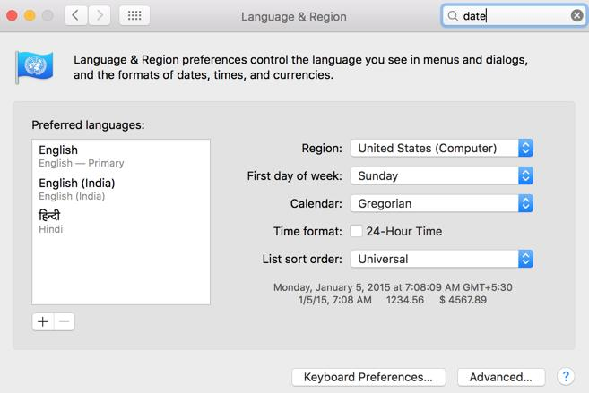
  - Open System Settings.
  - Select General → Language & Region.
  - Under Preferred Languages, click the + (Add Language) button.
  - Search for Hindi or Gujarati.
  - Select your preferred language and click Add.
  - If macOS asks whether you want to use it as your primary language, choose Use Hindi or Use Gujarati.
  - If prompted, restart or log out and back in to apply the change.

Step 3: Verify your changes:
- Confirm the new wallpaper appears on the desktop.
- Reopen Language & Region and verify that Hindi or Gujarati is listed as the preferred language.

4. Install a fresh copy of Ubuntu Linux (real or virtual machine) and create a new user account named 'gamer'. After installation, enable automatic login for this user and take a screenshot of the login screen showing the username.
Answer
Step 1: Download the required software:
- Download Ubuntu
- Get the official Ubuntu Desktop ISO.
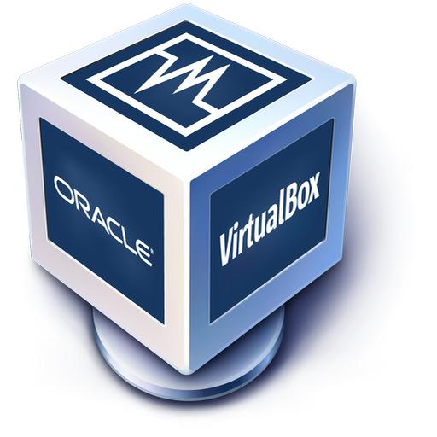
- Download VirtualBox
- This software lets you run Ubuntu in a virtual machine on Windows.

Step 2: Create your Ubuntu virtual machine:
- Install and open VirtualBox.
- Click New and enter Ubuntu Gamer as the virtual machine name.
- Select the downloaded Ubuntu ISO file.
- Allocate at least 4 GB RAM and 25 GB virtual disk space, if your laptop has sufficient resources.
- Start the virtual machine and follow the Ubuntu installation wizard.
- Create your account during installation. Set the username to exactly gamer and choose a password.
- Complete the installation and restart the virtual machine, removing the ISO when prompted if necessary.

Step 3: Enable automatic login:
- Open Settings.
- Select System → Users (the location may vary by Ubuntu version).
- Click Unlock and enter your password if requested.
- Select the gamer account.
- Turn on Automatic Login.

Step 4: Take the screenshot:
- Restart Ubuntu or log out to verify the login behavior.
- Confirm that the gamer account is configured for automatic login.
- Capture the screen showing the account name or login state. On Ubuntu, press PrtSc to open the screenshot tool, then save the image.
5. Use ChatGPT to generate a step-by-step guide for installing Windows 10 on a laptop, including partitioning tips and post-installation settings for privacy and updates. Follow the guide and note any steps that were unclear or missing.
Answer
1. Prepare before installation:
- A laptop that supports Windows 10.
- A reliable internet connection.
- A USB flash drive with at least 8 GB of space.
- A Windows license or existing digital license.
- A backup of all important files.
- Your laptop manufacturer's Wi-Fi and storage drivers, if needed.
2. Create the bootable USB:
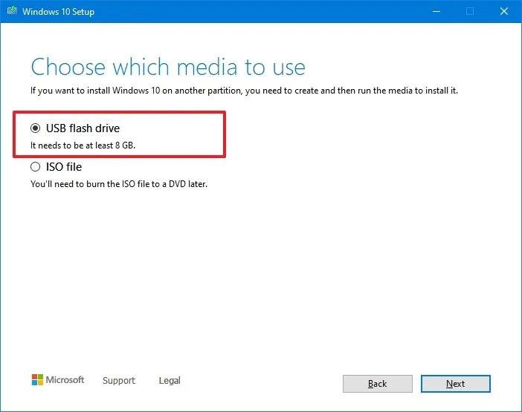
Step 1.
- Open the official download page and click Download Now under the
installation-media section.
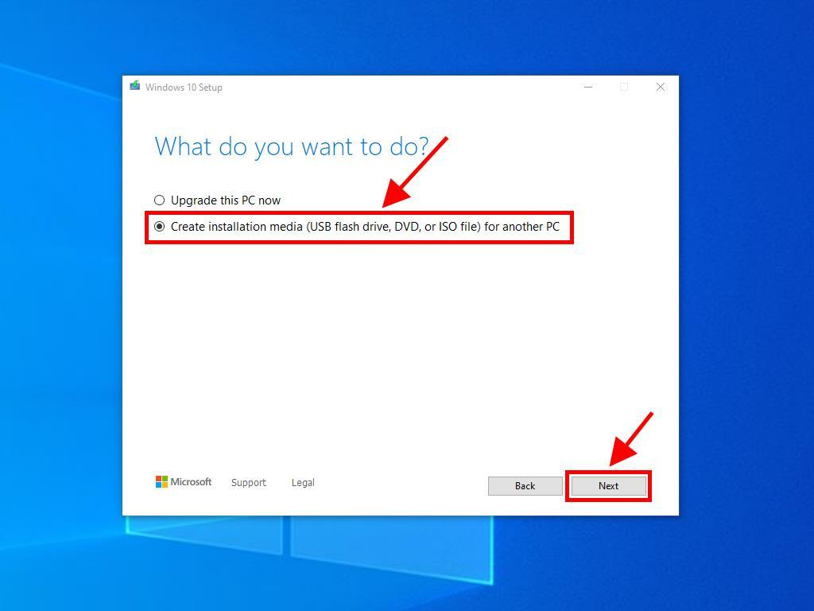
Step 2.
- Run the downloaded tool as administrator and accept the license terms.

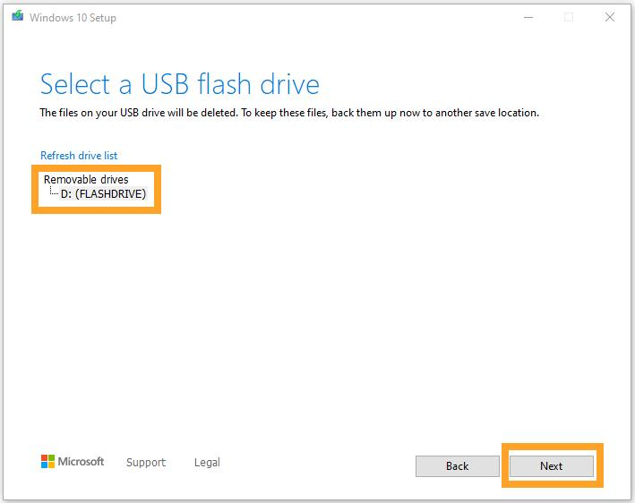
Step 3.
- Select Create installation media for another PC, choose the language and architecture, then choose USB flash drive.

3. Boot the laptop from USB:
- Keep the USB connected and restart the laptop.
- Open the boot menu. Common keys include F12, F9, Esc or F2, depending on the manufacturer.
- Select the USB drive, preferably the entry marked UEFI.
- At Windows Setup, select your language, time format and keyboard layout.
- Click Install now.
- Enter your product key if requested. If Windows was previously activated on this laptop, you can often select I don't have a product key and activate later using the matching edition and digital license.

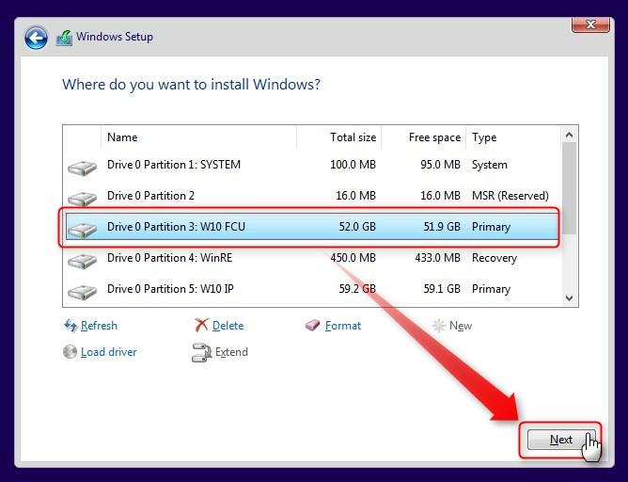
4. Partition the disk safely:

Partition choice | What it means
Existing Windows partition | May contain your current files and operating system
EFI/System or Recovery partition | Used to boot or recover Windows
Unallocated space | Disk space not currently assigned to a partition

5. Complete the first-time setup:
- Choose your region and keyboard layout.
- Connect to Wi-Fi when prompted.
- Create or sign in to an account.
- Set a strong password or PIN.
- Review privacy options rather than accepting every default automatically.

6. Configure privacy settings:
  - Diagnostics & feedback
  - Location
  - Camera and microphone
  - Advertising ID and app permissions

7. Configure updates and drivers:
- Open Settings → Update & Security → Windows Update.
- Click Check for updates where available.
- Install appropriate driver updates and restart when prompted.
- Check the laptop manufacturer's official support website for any missing Wi-Fi, graphics, audio or chipset drivers.
- Check Settings → Update & Security → Activation to verify activation.

Unclear:
- Finding the correct boot-menu key was unclear because it depends on the laptop manufacturer.
- Choosing the correct partition was confusing because several system and recovery partitions may appear.
- The option to skip entering a product key may not appear on every installation.

Missing:
- The guide should explain how to obtain Wi-Fi or storage drivers if Windows does not detect the hardware.
- It should explain how to confirm Windows activation after installation.
- It should mention that deleting partitions erases their data and that backups are essential.
- It should clearly explain that standard Windows 10 support ended on October 14, 2025, and discuss applicable extended security updates or upgrading to Windows 11.

